## The Components of the Welcome Screen

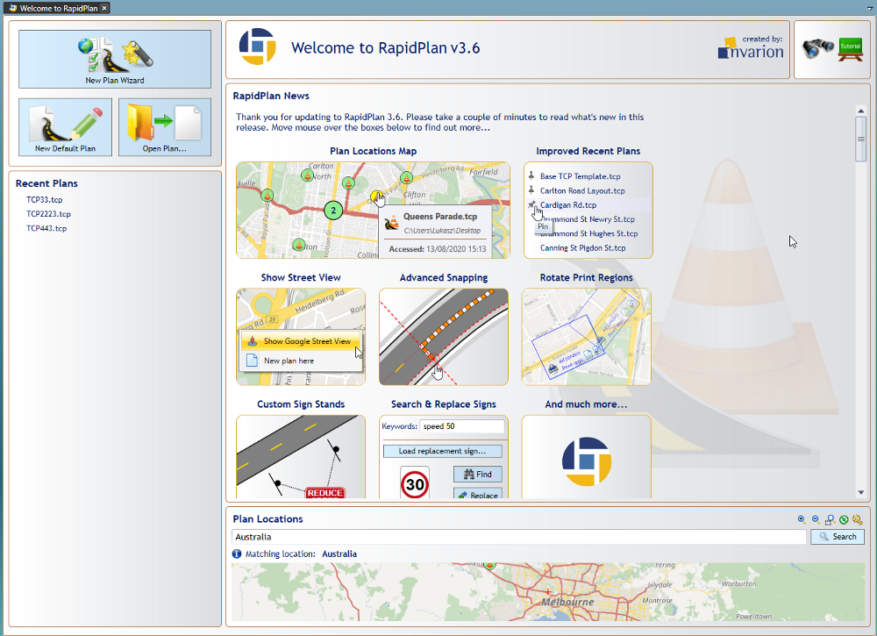

components

**New Plan Wizard**

Use the New Plan Wizard to quickly specify all properties of a new plan you’re creating. The wizard integrates the creation of five basic plan types: **Blank canvas**, **Base map**, **Static template**, **From PDF**, and **Auto template.**

**New Default Plan**

This selection provides you with a default canvas. Default plan settings can be amended and saved in **Tools > Preferences**.

**Open Plan**

Saved plans can be loaded with this selection.

**Recent Plans**

Recently saved plans can be quickly accessed from here, hovering over each plan will highlight them on the Plan locations map.

**Tutorials**

Selecting this takes you to the **Invarion RapidPlan YouTube** page where you have free access to video tutorials covering topics from the basic RapidPlan overview, using available tools and controls, up to some more advanced tips and uses.

**RapidPlan News**

This section provides you with the latest updates and news from RapidPlan.

**Plan locations**

The plan locations map plots your plans on a map. By clicking a pin, you can view plan information, such as when the plan was last accessed and modified. You can also right-click on a pin and select ‘Show Google Street View’ to see street view images in your web browser (subject to Street View image availability at the specific location).

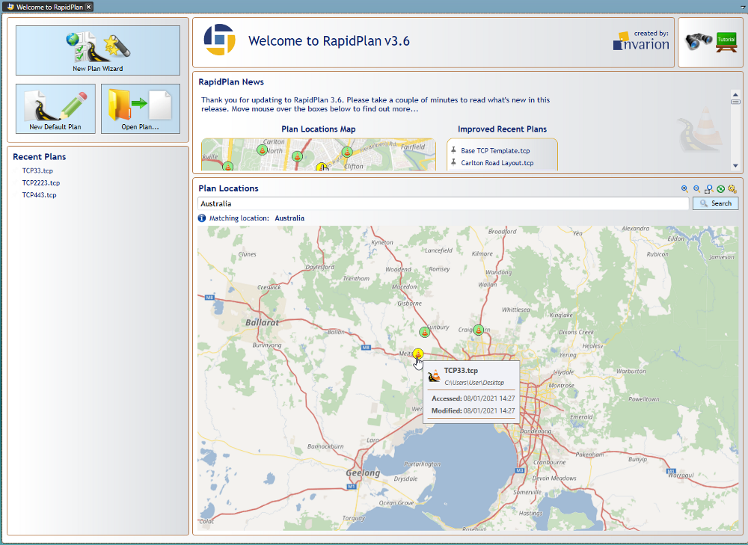

locations